**Act Report**

This communicates the insights and visualizations produced from the analysis process.

The dataset wrangled is the WeRateDogs twitter archive. WeRateDogs is a [Twitter](https://en.wikipedia.org/wiki/Twitter) account that rates people's [dogs](https://en.wikipedia.org/wiki/Dog) with a humorous comment about the dog. The account was started in 2015 by college student Matt Nelson. WeRateDogs asks people to send photos of their dogs, then tweets selected photos rating and a humorous comment. Dogs are rated on a [scale of one to ten](https://en.wikipedia.org/wiki/Scale_of_one_to_ten), but are invariably given ratings in excess of the maximum, such as "13/10". Popular posts are re-posted on Instagram and Facebook. In 2017, Nelson started a spin-off Twitter account, Thoughts of Dog.

The account also has a branded game, a popular online store, and a book that was published in fall 2017. Nelson and his team of four receive 800 to 1,000 submissions daily and work to narrow them down to about one high-quality piece of dog content per day.

The entire project was completed on jupyter notebook; however, the project is being supported with two reports exported as PDFs.

**Storing Data**

The cleaned data was stored in a CSV file named twitter_archive_master.csv which can be easily used for analysis and visualization

**Analysis and Visualization**

The cleaned data was analyzed and the following insights were deduced:

● The percentage of Dog stages

● The relationship between retweet count and favorite count

1. **The Percentage of Different Dog stages**

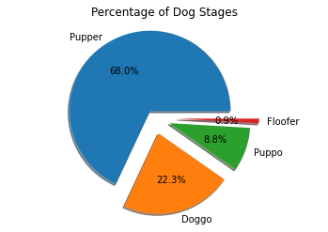

From the chart above, it can be deduced that:

● Pupper has the highest Dog stages with a share of 68%

● Floofer has the lowest Dog stages with a share of 0.9%

**B. Relatinship between Retweet and Favorite count**

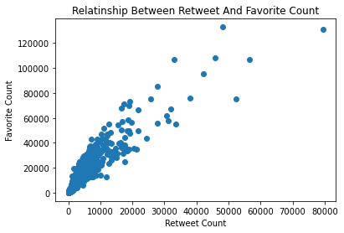

● From the plot, we can say there is a linear relationship between the two parameters